Relu Consultancy Hiring Challenge: Data Extraction Engineer (FTE)

Thank you for your interest in the Full-Time Data Extraction Engineer role at ReluConsultancy. This hands-on challenge is designed to assess your technical skills in web scraping, data processing, and attention to detail. We believe this is a great way for you to showcase your abilities on a practical, real-world problem.

We look forward to reviewing your submission. Good luck!

Challenge Objective 1:
Your task is to build a web scraper that extracts all the Cruise Data from disneycruise.disney.go.com. The scraper must follow the precise step-by-step instructions below, including handling navigation, pagination, data cleaning, and final storage.

🧭 Technical Specification: Step-by-Step Instructions
step 1: Navigate and Agree
- URL: https://disneycruise.disney.go.com/en-in/
- The Image is given below for reference.
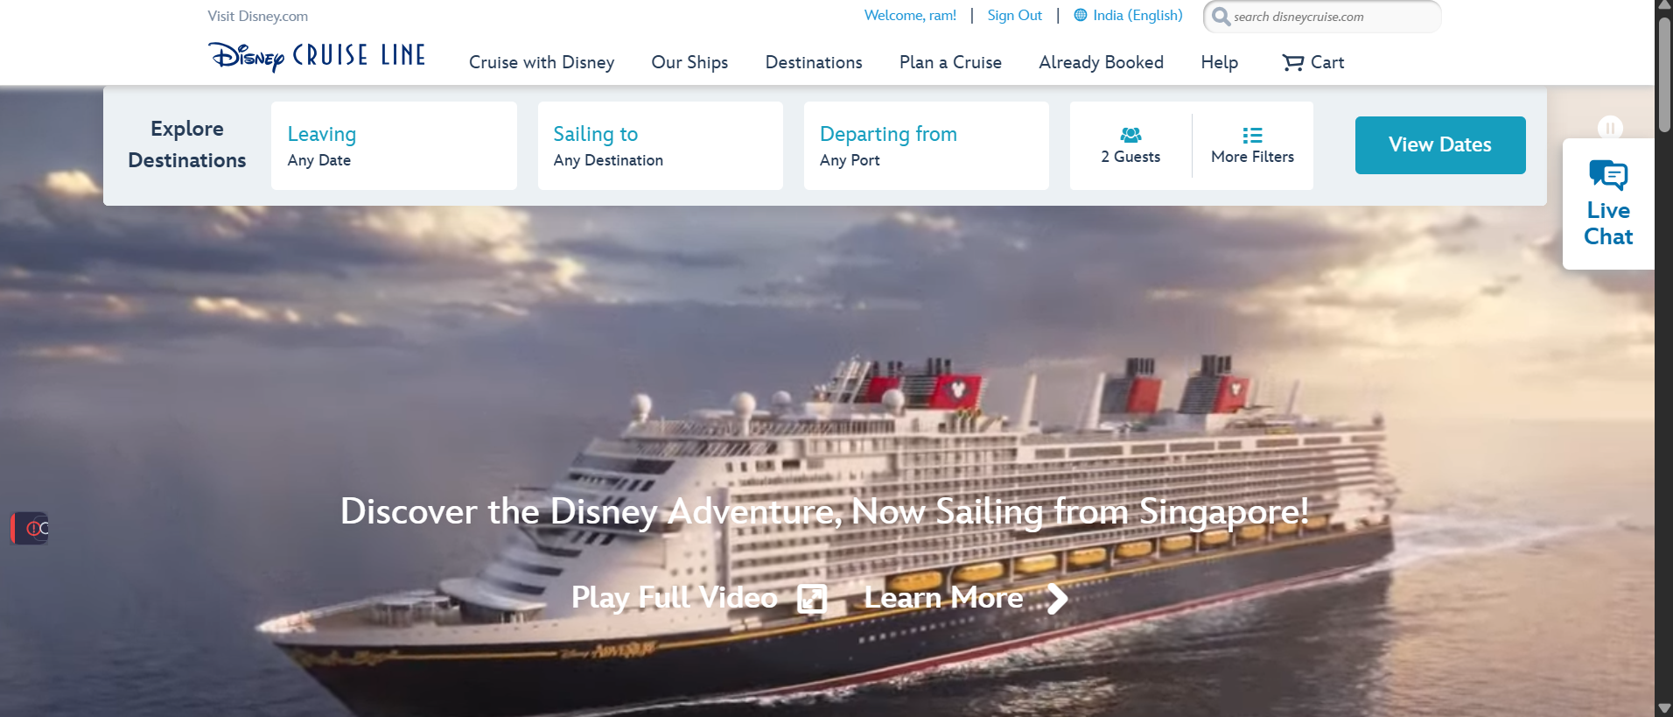

Step 2: Click on the Search Button
- Action: Programmatically click on View dates
- Choose the filters programmatically
- The Image is given below for reference.
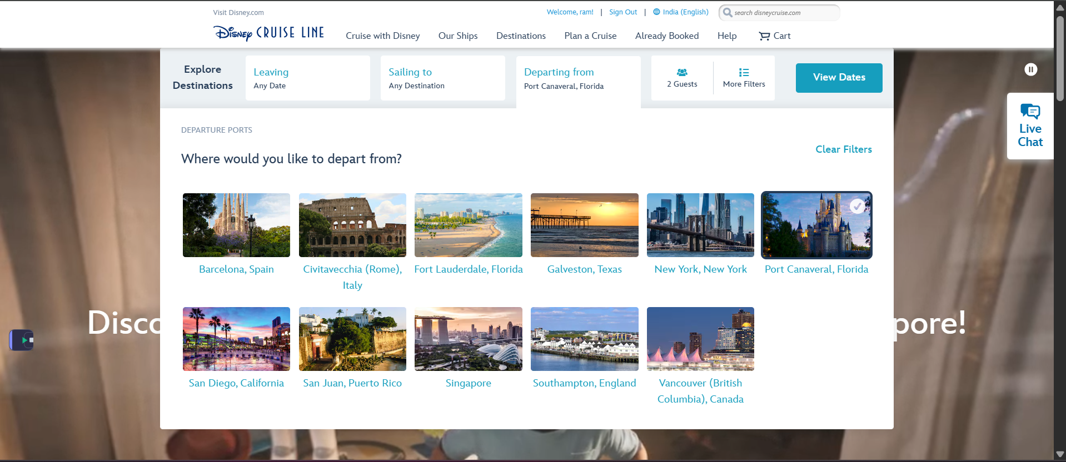

Step 3: Wait for the results load
- Action: Wait till all cards load.
- The Image is given below for reference.
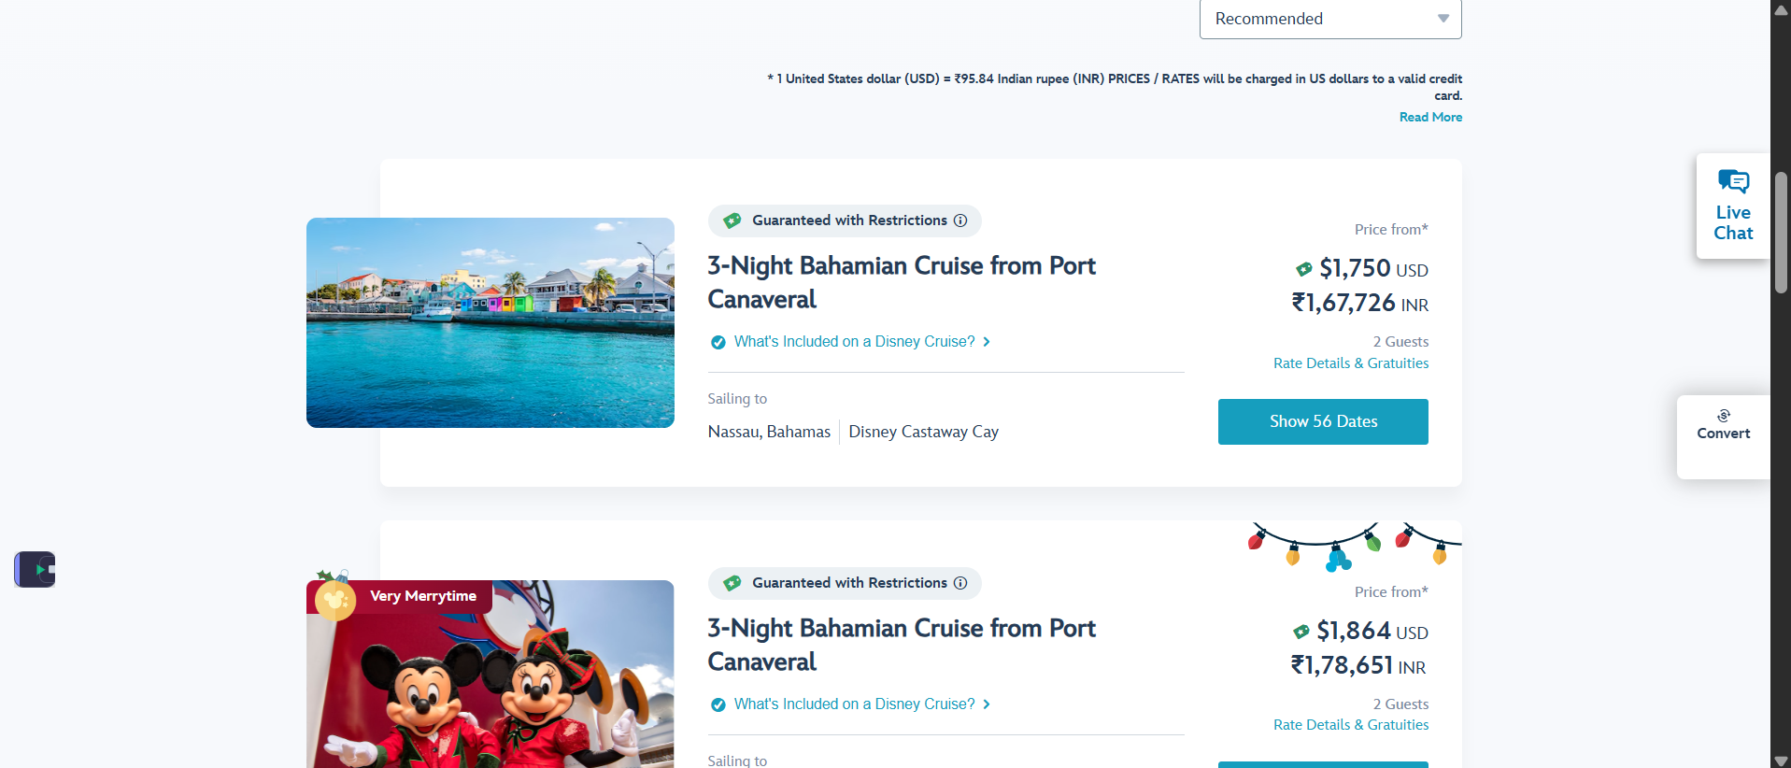

Step 4 : Collect data from each card
- Action: Scroll to the end of the page to extract all card data
- Collect data from each cruise card.
- Fetch at-least 35 pages.
- The image is given below for reference
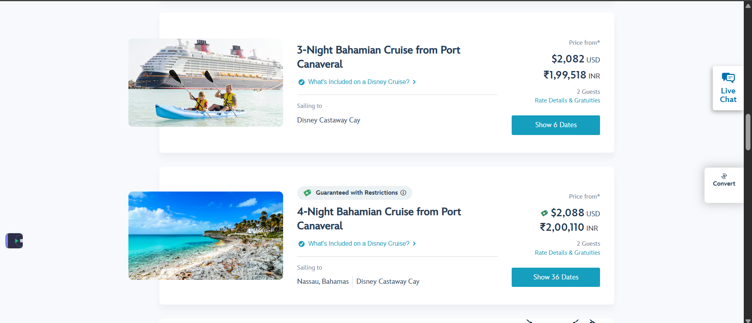

Step 5: Apply Data Cleaning Rules
Action: Perform Data cleaning on the extracted data and ensure no empty fields are present.
- Collect temporary data in json/csv.
- Ensure no duplicate data is present.
- Ensure locations are present and it shall not be empty.

Step 6: Store Data in CSV format

Action:
- Store the cleansed data into a .csv file.
- Data shall be clean.
- Proper columns shall be shown.

The image given below is for reference.
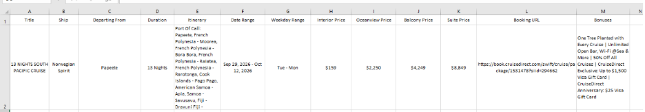

Additional Points:
- Content: Each column should contain the raw content (text)found under its corresponding section on the website.
- Completeness: The final CSV file should contain all records from all pages.

📋 Evaluation Criteria
Your submission will be evaluated based on the following criteria:
- Correctness & Completeness: The CSV file contains all records from the specified Search without duplicates, and the data is accurate.
- Data Cleaning: The cleaning rules from Step 5 are correctly implemented.
- Code Quality: Your code is clean, well-structured, readable, and includes comments where necessary.
- Robustness: The script handles potential issues like page load times and navigates the site reliably.

🚀 Submission Guidelines
- What to Submit:
- Source Code: A .py python file and upload it to google Collab with a sharable link.
- Output File: The final results.csv file generated by your script and .py and google Collab link.
- Answers to the following Questions: Answers must be printed in the terminal output and entered in the google form fields provided.
(i) How many total cruises are there for the Pacific as a destination? (count)
(ii) How many total cruises are there?
(iii) How many holiday cruises are there?
(iv) How many Cruises offer more than 2 dates for booking?
(v) How many cruises do Miami and London have as departure ports?
- How to Submit:
- Please upload all your files (or the link to your Git repository) via the official submission form:
- Submission Form:https://forms.gle/88e7tcW1boyZdL1y9

Challenge Objective 2:
Your task is to build a web scraper that extracts all the company and ingredients data from ingredientsnetwork.com.
The scraper must follow the precise step-by-step instructions below, including handling navigation, pagination, data cleaning, and final storage.

🧭 Technical Specification: Step-by-Step Instructions

step 1: Navigate
- URL: https://www.ingredientsnetwork.com/
- Action: visit the website programmatically
- The Image is given below for reference.
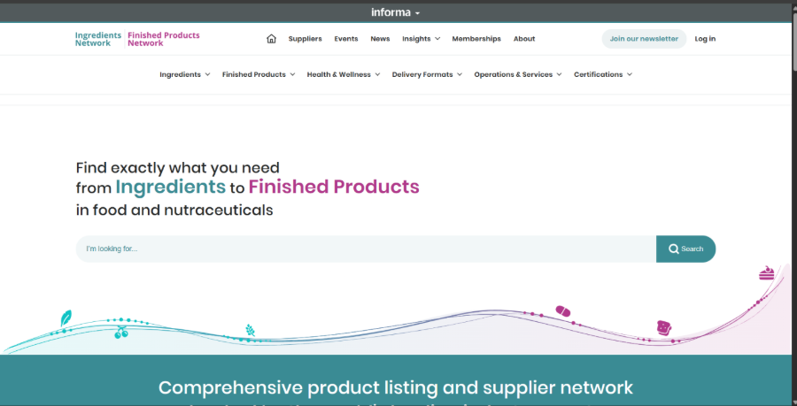

Step 2: Click on the Search Button
- Action: Programmatically click on Search.
- The Image is given below for reference.

Step 3: Wait and extract
• Action: Wait for page to load and extract data from all cards
• The image given below is for reference. 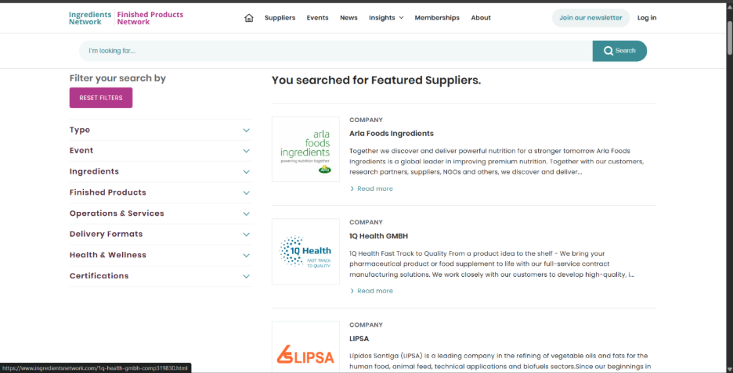

Step 4: Data Cleaning
Required fields: -
- Company Name
- Company Description
- Sales Markets
- Primary Business Activity
- Categories
- Events
- Address
- Email
- Telephone
- Website

Action:
- When extracting these columns are must, the data shall not be inaccurate nor empty.
- Before cleaning, store it in a temporary csv.

Step 6: Store Data in CSV format
Action:
- Store the cleansed data into a .csv file.
- Data shall be clean.
- Proper columns shall be shown.
The image given below is for reference.

Additional Points:
- Content: Each column should contain the raw content (text)found under its corresponding section on the website.
- Completeness: The final CSV file should contain all records from all pages.

📋 Evaluation Criteria
Your submission will be evaluated based on the following criteria:
- Correctness & Completeness: The CSV file contains all records from the specified Search without duplicates, and the data is accurate.
- Data Cleaning: The cleaning rules from Step 4 are correctly implemented.
- Code Quality: Your code is clean, well-structured, readable, and includes comments where necessary.
- Robustness: The script handles potential issues like page load times and navigates the site reliably.

🚀 Submission Guidelines
- What to Submit:
- Source Code: A .py python file and upload it to google Collab with a sharable link.
- Output File: The final results.csv file generated by your script and .py and google Collab link.
- Answers to the following Questions: Answers must be printed in the terminal output and entered in the google form fields provided.
(i) How many total ingredients are there? (count)
(ii) How many total finished products are there?
(iii) How many companies have herbs and spices?
(iv) How many companies have physical delivery formats?
(v) How many companies are in Cognitive & Mental Health?
- How to Submit:
- Please upload all your files (or the link to your Git repository) via the official submission form:
- Submission Form:https://forms.gle/88e7tcW1boyZdL1y9

🏆 Bonus Challenge — Optional

For candidates who would like to go the extra mile, we have included an optional bonus challenge.

The bonus challenge focuses on data persistence, data presentation, and deployment. Completing the bonus is optional, but it provides an opportunity to demonstrate additional practical skills beyond the core scraping requirements.

🔹 1. Data Persistence

Create a Supabase Account
- Sign up for a free Supabase account.
- Create a Supabase project.
Set Up Your Table
- Create a database table matching the structure of your scraped data.
- Ensure the table contains the relevant fields from your cleaned dataset.
Upload Your Data
- Upload your cleaned CSV data into the Supabase table.
- Ensure the data is stored correctly and can be retrieved from the database.
Alternative:
If you prefer not to use Supabase, you may use your final cleaned CSV file as the data source for the web application.

🔹 2. Data Presentation & Deployment

Build a Simple Web App
- Build a simple web application using any framework you are comfortable with, such as Flask, FastAPI, Next.js, or another suitable framework.
- Display the scraped data in a clean, readable tabular format.
- Include the relevant data collected through the challenge.
- Connect to Supabase
If you choose to use Supabase:
- Connect your web application to your Supabase database.
- Fetch the stored data from Supabase.
- Display the data dynamically on the webpage.
Deploy Online
Deploy your application using a free or suitable hosting platform, such as:
- Render
- Replit
- Railway
- Or another suitable hosting platform
If you complete the bonus challenge, please provide the live application URL in the submission section of this form.

Rules & Support
- You may use any programming language and libraries you are comfortable with (e.g., Python with Selenium/Playwright/Scrapy, Puppeteer, etc.).
- Your submission must be your own original work.
- Please be respectful of the target website—do not send an excessive number of requests in a short period.
For any queries or doubts regarding the challenge, please contact us at: hiring@reluconsultancy.in
For more information about our company, please visit: reluconsultancy.com

